**High level Design(HLD)**

**Insurance Premium Prediction**

**Revision no:1.0**

**Last date of revision:21/04/2023**

**Documents version control**

|  |  |  |  |
| --- | --- | --- | --- |
| **Date issued** | **Version** | **Description** | **Author** |
| **21/04/2023** | **1** | **Initial HLD -v1.0** | **Akhil Pratap singh** |
|  |  |  |  |
|  |  |  |  |
|  |  |  |  |

**Contents .**

**Documents version version control…………………………………….2.0**

**Abstract………………………………………………………………………………4.0**

1. **Introduction……………………………………………………………………5**
   1. **Why this high level design documents?........................5**
   2. **Scope………………………………………………………………………….5**
   3. **Defination…………………………………………………………………..5**
2. **General Description…………………………………………………………….6**
   1. **Product perspective………………………………………………………6**
   2. **Problem Statement……………………………………………………….6**
   3. **Proposed Solution…………………………………………………………6**
   4. **Data Requirements……………………………………………………….6**
   5. **Tool Requirements………………………………………………………..6**
   6. **Constraints……………………………………………………………………7**
   7. **Assumptions…………………………………………………………………7**
3. **Design Detail………………………………………………………………………8**
   1. **Model training……………………………………………………………8**
   2. **Deploymet process……………………………………………………9**
   3. **Event log …………………………………………………………………….10**
   4. **Error handling……………………………………………………………..10**
   5. **Performance……………………………………………………………….11**
   6. **Reuseability………………………………………………………………..11**
   7. **Application Compatibility…………………………………………….11**
   8. **Resource Utilization…………………………………………………….11**
   9. **Deployments……………………………………………………………….11**
4. **Conclusion……………………………………………………………………………11**

Abstract

In the recent time people are bussy they are not aware of health as much as they should ,they does not have enough time to consult a medical expert to take insurance plane ,so we are providing a solution that can help to reduce this problem. people should know some information about themself and they can get a solution

About insurance.

1. **Introduction**
   1. Why this is High Level Design Document?

The purpose of high level design document is to add necessary detail to the current project description to represent a suitable model for coding.it can also be used for how model interact at high level.

**The Hld will**

* Present all the design and aspect and define them in detail
* Describe the user interface being implemented
* Describe the hardware and software interfaces
* Describe the performance requirements
* Include design feature and architecture of the project
* List and describe the non fuctional attributes like
* Security
* Reliability
* Maintainability
* Portability
* Reuseability
* Serviceability
  1. **Scope**

The HLD documents presents the structure of the system,

Such as application flow and technology architecture The hld uses non technical to mildly technical which should be understable to administrators of the system.

* 1. **Definations**

|  |  |
| --- | --- |
| Term | Descrption |

IDE Intregeted development enviroments

AWS amzon web services

**2 General description**:

2.1 product perspective

Insurance premium prediction is machine learning based salution which will help to know about our health insurance premium

2.2 Problem statement

The goal of this project is to give people an estimate of how much they need based on their individual health situation.

2.3 Preposed solution

Based on problem statements we have draw a solution Using machine learning that can give you a estimate based on that you can work with any insurance policy company.

2.3 Data Requirements

We need data completely based on problem statements proper balanced data set to train our model

**2.4** **Tool Used**

Python programming language Numpy ,pandas ,sklearn, vs code,flask ,HTML,git .

* Vs code used as ide
* For functional operation we used numpy and pandas
* For visualisation we used matplotlib ,seaborn
* AWS is used for deployment
* Frontend develop is used HTML
* Python flask using for backend
* Github is used for version control system

**2.5 Constraints**

Insurance premium prediction system must be user friendly as automated as possible .User should not required to any kind of workings.

**2.6 Assumptions**

The main objective of the project to implement the use cases as previously mentioned for new data set that comes from user give the right and proper estimate .it is also assumed that all aspects have the ability to work with expectation.

**Design Details**

**3.1 Process flow**

To predict premium we use machine learning model that flow diagram shown In below

**Proposed methodology**

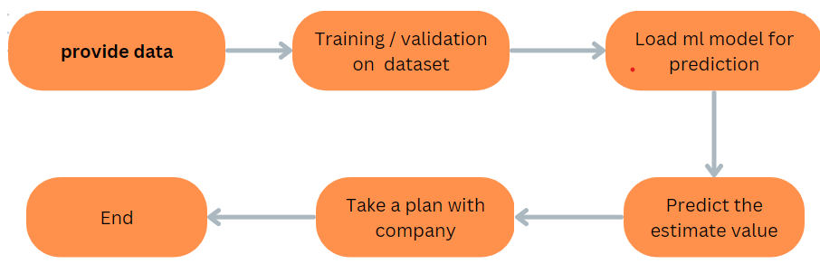

3.1 Model training and evaluation stage

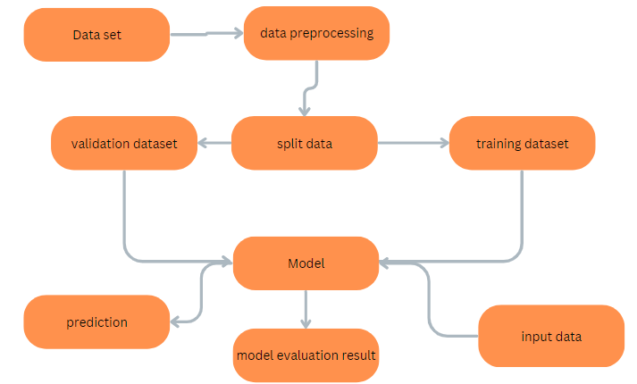

**3.2Deployment process:**

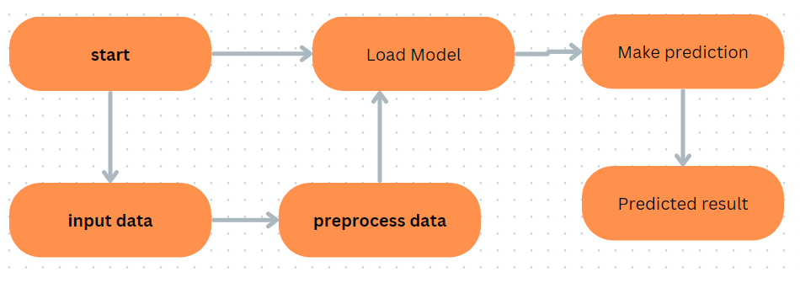

**3.2 event log**

The system should log every event so that user should know that process is running internally

We use the logging because we can debug our code easly

**3.3 Error handling**

We use error handling for encountering the problem which comes from modules and specially from which line

**3.4 Performance**

Insurance premium services is used for predict premium so that user can take action to work with any insurance company , because it related to health so that it should accurate as possible also model training is important to improve the performance.

**3.5 Reuseability**

The code is written in this way that we can reuse our code with no problem.

**3.6** **Application Compatibility**

The different components for this project will use python to intract between them. eatch component have its own task to work and it is job of python to ensure that information transfer should be proper

**3.7 Resource Utilization**

When any task is performed it will likely use all the processing power is available util that function is finished .

**3.8 Deplyment**

We deploy our model in AWS .

**4.0 Conclusion**

Insurance premium prediction is trained to predict based on estimate expense for our insurance based on various factors to help people to have idea for health insurance based on predicted expense we can take our insurance plan from any company .